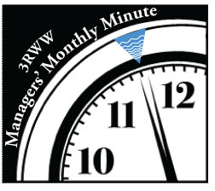
Manager’s Minute 2017

January 2017:

3 Rivers Wet Weather has a new Executive Director: Mark Wolinsky officially took over the reins of 3RWW on Jan. 1, 2017 following John Schombert’s retirement. Mark had joined our organization in late May 2016 as Deputy Director, so those of you who have met and interacted with him over the last seven months have experienced his enthusiasm and energy for tackling our region’s ongoing wet weather issue. In addition to his passion for sewage, he also brings a wealth of experience from his 27 years with the Hempfield Township Municipal Authority serving in many capacities, including Sewage Treatment Plant Operator, Environmental Programs Administrator and most recently as Assistant Manager, and a four-year stint as Pretreatment Administrator for Cranberry Township. As a Board Member for the Western Westmoreland Municipal Authority, Mark is familiar with addressing many of the same issues Pittsburgh is facing. He is perfectly positioned to provide continuity and leadership for 3RWW’s municipal support programs and long-term goals, and looks forward to working with all of you. Feel free to contact Mark at any time at 412-578-7962 or mwolinsky@3rww.org.
February 2017 Update:
Municipal managers, solicitors and elected officials are encouraged to attend an important meeting to be held by the Allegheny County Watershed Plan Advisory Committee (WPAC) at the Green Tree Municipal Building on February 15 from 6:00 – 8:00 p.m. The meeting will focus on the municipal ordinance requirements that are part of the Allegheny County Stormwater Management Plan (SWMP). This will be the last WPAC meeting before the SWMP and Model Ordinance are submitted to Allegheny County Council for review and adoption. After adoption by the County, the SWMP will be forwarded to PADEP for approval. Within six months of PADEP’s approval, each municipality will be required to adopt ordinances consistent with the plan. For questions regarding the SWMP or to RSVP, contact William McClain at 412.350.1361 or wmclain@alleghenycounty.us.
Information on the Allegheny County SWMP and a copy of the revised Model Ordinance are available at the project website www.alleghenycountyswmp.com/.

March 2017:
During a visit to Allegheny County in June 2014, EPA shared its expectation for municipalities to focus on source flow reduction as an important component of the region’s long-term wet weather plan. When PADEP/ACHD issued interim municipal consent orders in 2015, the communities were required to begin evaluating source flow reduction opportunities. In addition, ALCOSAN began preparing a response to a Section 308 Request for Information mandating evaluation of municipal flow targets.

In 2015 to help facilitate the region’s focus on these important issues, 3RWW, ALCOSAN and municipal stakeholders began collaborating as part of the Source Flow Reduction and Flow Target Subcommittee (SFRFT). The goals of the SFRFT Subcommittee include developing a consensus–based municipal plan for source flow reduction and flow targets in both separate and combined sewer systems, and supporting the ALCOSAN Interim Wet Weather Plan implementation through cost-effective removal of infiltration and inflow.

Along with a cover letter, attached you will find two documents: an interim report developed by the SFRFT -- which includes details of the work of the subcommittee, proposed interim investigative flow target thresholds for combined, separate, and hybrid systems as well as proposed initial implementation steps -- and the Executive Summary of that report.

The purpose of this report is twofold:
· To provide a consensus-based summary document from a municipal perspective, which addresses Interim Investigative Flow Target Metric Thresholds as a resource to ALCOSAN’s January 2017 response to the 308 letter received from the EPA.
· To provide a consensus-based framework for acceptance by the municipalities of a compliance process and Interim Investigative Flow Target Metric Thresholds for incorporation into potential regulatory implementation orders.

Please take some time to review these important documents; please also share them with your council. If you have any questions, comments, or require additional information, please contact
Mark Wolinsky, Executive Director of 3 Rivers Wet Weather at mwolinsky@3rww.org or 412-578-7962.

April 2017:

MS4 Compliance

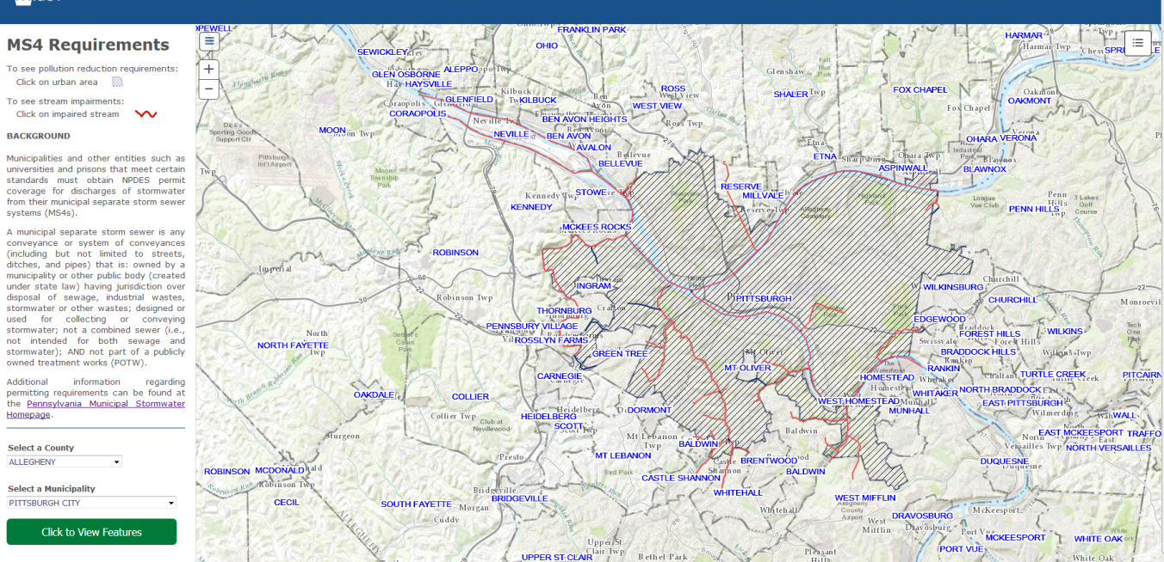

Important deadlines are coming for municipal NPDES permit holders!

General permit holders must apply using the Notice of Intent, and individual permit holders apply using the application. Submit your renewal 180 days before your permit expires, so your permit expiration date – 180 days = the NOI or application date.

Mark your calendar:
• August 3, 2017 is the last day for you to post your Pollutant Reduction Plan (PRP) or TMDL for public comment.
• September 16, 2017 is the last day to submit your NOI/Application for all general permits and individual applications that expire or have TMDL requirements.
DEP has some useful links for municipal separate storm sewer system (MS4) resources on its website, including guidance for mapping, calculations, modeling and Minimum Control Measure (MCM) implementation. Check out the web-based GIS application that provides a visual map of the information in the MS4 requirements table, including the impaired streams by municipality and county, and designated urban areas.
If you have any questions, don’t hesitate to contact the Bureau of Clean Water (BCW) at
RA-EPPAMS4@pa.gov, or by phone at 717-787-5017.
Please note that there will be an MS4 presentation at the upcoming 3WG meeting on April 13 at 9 a.m. at the Green Tree Municipal Building.

May 2017:
As part of the Source Reduction Studies due December 1, 2017 under the current Phase I municipal consent orders, communities must submit a GIS map that includes certain information. To assist municipalities with the process, 3 Rivers Wet Weather will hold a mapping workshop for both separate and combined communities on May 25 at the Green Tree Municipal Building from 9-11 a.m. The workshop will focus on the process for mapping flow monitoring data to show areas of high infiltration and inflow, as well as potential areas for green infrastructure and source reduction. An invitation will be sent to municipal managers and engineers in the near future.

The content of the workshop will be based on the work of the 3RWW Consent Order Working Group (COWG), a technically-focused group of municipal representatives that meets monthly. The group collaborates to develop standardized tools for municipalities to use to comply with the consent orders. Tools include a standard template for the Source Reduction Studies and a GIS map that satisfies consent order requirements.

If you, your elected officials, and/or your engineer want to get more involved with COWG or other 3RWW working groups, please give us a call at 412-578-8375 or email us at info@3rww.org. Your input is crucial as we work together for clean water throughout the region.

June 2017:
3 Rivers Wet Weather would like to take this Manager’s Minute as an opportunity to thank ALCOSAN and its Board of Directors for approving 3RWW funding at their April 27 meeting. This funding will allow us to continue our support of the ALCOSAN customer municipalities. Toward that end, we are pleased to announce that 3RWW has hired a new program coordinator: Sara Rectenwald. You may have met Sara at a recent 3RWW meeting as she joined our team in early April to help develop and implement tools, resources and programs for municipalities. Sara most recently worked as an associate scientist at Environmental Resources Management in Cranberry Township. She has worked on a number of research projects, including a well water and surface water quality study at Duquesne University, where she will soon complete her Master’s in Environmental Science and Management. While earning her Bachelor of Science degree in Biology at Allegheny College, Sara participated in a Marine Program at Duke University as a Harvey Smith Scholar. Sara will play an important role in 3RWW’s work of assisting our municipalities.

July 2017:
To continue the region’s progress on the wet weather issue, 3RWW is requesting that municipalities provide updated flow monitoring data where available. The last system-wide flow monitoring study was conducted in 2008 across the ALCOSAN service area. Since that time, some municipalities have conducted site-specific flow monitoring and/or flow isolation studies that help to provide a more current picture of our regional system.

We are requesting the location and data from these municipal projects so that we may more efficiently and cost-effectively address the wet weather issue together. This data will help to avoid duplication of effort as ALCOSAN explores potential locations for flow monitoring and flow-isolation studies which they have offered to conduct in the service area. It will also allow 3RWW to eventually add this information to its comprehensive system-wide database designed to be an accessible resource for continued collaboration among municipalities.

Please share this request with your engineers and council representatives. If you have any questions or would like to discuss how to send the information, please contact 3RWW Executive Director Mark Wolinsky at 412-578-7962 or mwolinsky@3rww.org.

August 2017:
As the summer flies by, important regulatory deadlines loom for communities in their efforts toward meeting compliance requirements (some more looming than others).

For the municipal consent orders:
August 1, 2017 – Municipalities need to have completed at least one flow reduction demonstration project.
December 1, 2017 – Municipalities need to submit their Source Reduction Studies to the regulatory agencies and ALCOSAN.

For MS4 communities:
August 3, 2017 – The last day for you to post your Pollutant Reduction Plan (PRP) or Total Maximum Daily Load (TMDL) for public comment.
September 16, 2017 - The last day to submit your Notice of Intent (NOI)/Application for all general permits and individual applications that expire or have TMDL requirements.

And if those deadlines aren’t daunting enough, also looming is budget season - as you crunch numbers, please bear in mind MS4 goals over the next 5 years, as well as your current and anticipated future obligations in meeting wet weather challenges.

SAVE THE DATE: Stormwater Bus Tour for local government officials – Friday afternoon, September 22, 2017 - Stay tuned for more details.

September 2017:
As you know, your Phase I COA Source Reduction Study is due on December 1. As requested by the municipalities, a set of templates for the study has been developed by the 3RWW Consent Order Working Group (COWG). The attached templates, tailored for combined, separate and mixed communities, will need to be modified for your specific municipal source reduction study. Attached, you will also find a letter providing more details. Finally, the Source Flow Reduction and Flow Target (SFRFT) Subcommittee’s Interim Report is included as a supporting document to the template.
If you, your engineer, solicitor or council members have any questions, please don’t hesitate to contact Mark Wolinsky at (412) 578-7962 or mwolinsky@3rww.org.
October 2017:
Since it is budget season, please remember that a Sewer System Operating Budget template is available on 3RWW’s website. Sample line items include administration, legal, engineering, regulatory compliance, and maintenance costs related to your sewer systems and the consent orders. We have also recently updated the template to include a section and line items for MS4 programs. You can download the template from the Municipal Tools page of the 3RWW website (under the Budgets heading).
Please share this with your engineers and council representatives. If you have any questions, don’t hesitate to contact Mark Wolinsky at (412) 578-7962 or mwolinsky@3rww.org.
Reminder! Remember to register for the 3 Rivers Wet Weather Sewer Conference, October 11-12 at the Monroeville Convention Center.

